Alleosfour, A., Church, I., & Brown, C. (2020) A Three-Dimensional Hydrodynamic Model to Study the Baroclinic Conditions of the Bay of Fundy. *Manuscript in Preparation.*

**A Three-Dimensional Hydrodynamic Model to Study the Baroclinic Conditions of the Bay of Fundy**

Ahmadreza Alleosfour

Department of Geodesy and Geomatics Engineering

Fredericton, Canada

[aalleosf@unb.ca](mailto:aalleosf@unb.ca)

The Bay of Fundy is home to a diverse biological environment, and to provide marine protection plans and better insight on the species communities on the seafloor, benthic habitat mapping is required. These maps are based on an integration of seabed bathymetry, backscatter and physical oceanographic layers such as temperature, salinity, and currents from ocean models. For this study, the Finite-Volume Community Ocean Model (FVCOM) has been adopted, which covers the Bay and includes the Saint John River up to Evandale. The horizontal resolution ranges from 10m to 6000m in the Reversing Falls and open boundary respectively, and in the vertical coordinate, the model consists of 40 terrain-following layers.



The presence of strong tidal forces, especially in the Minas Passage, the complex geometry of the Saint John River, and the huge river runoff at the freshet is the most important challenges in this area. The model is forced to run by the tidal elevation, temperature, and salinity at the open boundary close to the Bay entrance and river water level, salinity, and temperature at the upper part of Saint John River. The model has been initialized with the temperature and salinity from a lower resolution regional model. The model results were evaluated with observational data and present good agreement with tidal elevation, gyre locations, the high tidal current locations, temperature, and salinity. Also, the model was able to capture the freshwater discharge from Saint John River to the north of Grand Manan Island.

**Keywords**: Bay of Fundy, FVCOM, High-resolution model, Saint John River, Baroclinic Condition

**1 Introduction**

The seabed ecosystem is affected by human activities such as fishing, oil and gas pollution, and mining which reduce benthic biodiversity and without a supportive plan to manage the resources and protect the ecologically sensitive areas, the marine ecology will collapse (Worm et al., 2006). However, benthic habitat mapping provides the location, condition, and extent of the marine ecosystem and the insight for decision-makers to apply precautionary practices (Brown et al., 2011). The water column attributes, and the seafloor geological conditions affect benthic biology. The former can be acquired by acoustic survey methods and the later can be derived from point sample of oceanographic measurement or the continuous coverage from ocean models (Anderson et al., 2008; Brown et al., 2011). The Bay of Fundy (Fig. 1a) is located on the west coast of the North Atlantic and northeast of the Gulf of Maine between two Canadian Provinces, New Brunswick, and Nova Scotia. The Minas Basin and Chignecto Bay are the most important sub-basin in the northeast of the Bay affecting by the tide and play an important role in sediment distribution in the Bay of Fundy (Shaw et al., 2014). The Bay is a unique area with the highest tide in the world, a diverse ecosystem and marine recourses (Li et al., 2015). The tide is predominantly semidiurnal (Swift et al., 1969) and range from 6.4 m at the mouth in the Grand Passage area to 13 m at the head, and 16 m in the spring tide at the Minas Basin (Swift et al., 1969; Garrett, 1972; Greenberg, 1983; Mossman, 2001; O’reilly et al., 2005;CHS 2006), which makes this region experience interesting tidal-related processes. The funnel shape, length, and gradually decreasing depth to the head of the Bay result in being in near resonance by the Atlantic tide which generates this high tidal range in the area which is predominantly from semidiurnal M2 (Redfield, 1950; Swift et al., 1969; Garret, 1972; Mossman, 2001; Shaw et al., 2010). Tide and tidal current are dominant factors on the changes in geology like erosion and sediment transport (Percy et al., 1997; Li et al., 2015) and affecting the interaction of biological, physical and chemical conditions of Bay (Mossman, 2001).

The main contribution of water to the Bay is from Scotian Shelf water (Xue et al., 2000 ) which enters the Bay along the Nova Scotia coast undertaking mixing up to the head of the Bay (Bailey et al., 1953) and flows out along the New Brunswick side and eastern part of Grand Manan Island (Bigelow,1927; Godin, 1968; Greenberg, 1982; Brooks, 1993) and combines with the Gulf of Maine circulation (Hachey and Bailey,1952; Dickie,1955; Godin,1968). The main source of freshwater in the Bay is the Saint John River discharge having complex bathymetry, large tides, dynamic River input, and strong currents in narrow passage. The river has a 55,000 km2 watershed (Fig. 1b) with an annual average discharge of about 1100 m3s-1 (Cunjak and Newbury 2005, Fig. 1b) with a maximum discharge of 5000 m3s-1 at the freshet time (Paquin et al., 2019). The near-surface circulation in the Bay is affected by the river runoff, especially in the Spring season (Aretxabaleta, et al., 2008), and has less impact on the deeper part of water column (Chao and Boicourt, 1986; Brooks, 1994). Finally, the flow joins the East Maine Coastal current (Brooks and Townsend, 1989; Brooks, 1994; Lynch et al.,1997) with most flow coming from the west of Grand Manan Island (Watson, 1936; Brooks, 1994; Lynch et al., 1997) and part of it from east of the Island (Aretxabaleta et al., 2009). Also, the river provides 30 percent of freshwater contribution to the Gulf of Maine system (Apollonio 1979; Brooks, 1994; Pettigrew et al., 1998). All these unique features potentially can impact the barotropic and baroclinic conditions of the Bay of Fundy.

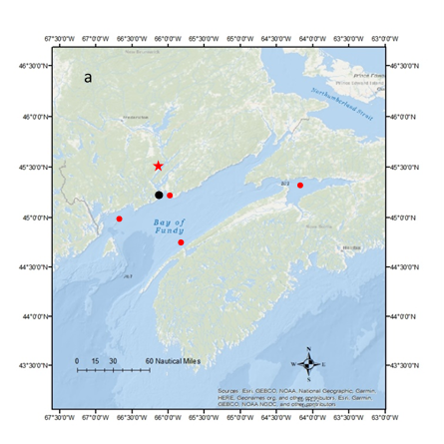

Figure 1. Bay of Fundy and the location of Oak point station (in red star) and Saint John River tide gauge (in black circle), and red circles are the location for tidal analysis,b)The Saint John watershed(from Cunjak and Newbury 2005)

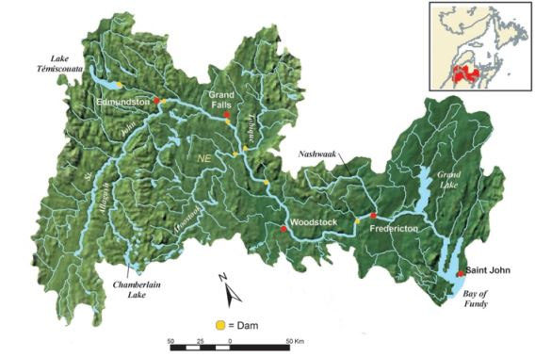

b

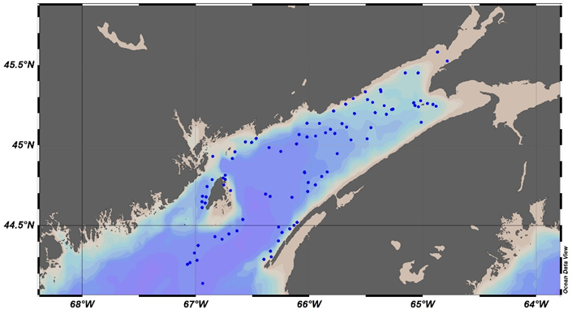

Figure 2. Location of CTD casts from fieldwork and World Ocean Database (created by Ocean Data View)

There has been a significant amount of research on the barotropic condition of Bay of Fundy using different model configuration such as the structured models ( Greenberg, 1979, Sankaranarayanan et al., 2003), and unstructured ones, (Dupont et al., 2003, 2005, Wu et al., 2011, 2014). These models usually simulate the tidal and wind-derived variation of sea level and currents. Resolving the baroclinic condition of Bay improves the emergency response (oil spill) (Paquin et al., 2019) and the transition between well-mixed and stratified zones which are important from a biological perspective (Pingree 1975; Denman and Herman,1978). However, A few studies focused on the baroclinic condition of Bay, mostly lower parts of Bay and Gulf of Maine. Watson, 1936, showed that the counter-clockwise gyre at the mouth of Bay is mostly driven by density effects while the tidal rectification and density-driven circulation (Aretxabaleta et al., 2008) resulting from surface heating (Garret et al., 1978) and freshwater inflow (Brooks, 1994) could be the driving factor together. Also, tidal current and coastal processes may be affected by variations of temperature and salinity resulting from the surface and open boundary heat and freshwater fluxes (Katavouta et al., 2016). One contributing factor which increases the model skill is how good the model can resolve the dynamic processes on the ocean domain, and this comes from the mesh resolution on which the model is running. The oceanic process properties vary on many scales which are dependent on factors such as coastline, bottom topography variation, the forcing meteorology, changing Coriolis force with latitude and the Rossby radius of deformation (Greenberg et al., 2007). Coastal models usually require increased spatial and temporal resolution to provide accurate forecasts (Garvine,1995; Chant,2011) by capturing a wider energy spectrum in the model and improving our understanding of oceanic sub-mesoscale dynamics (Soufflet et al., 2015), such as capturing the freshwater front from river discharge (Bricheno et al.,2013) or an accurate representation of sea surface temperature (Paquin et al., 2019). However, this leads to an increase in computation time, the requirement for extra computer storage space, and decreasing the model time steps to satisfy the computational fluid dynamic stability condition (Courant-Friedrichs-Lewy, CFL) (Greenberg et al., 2007; Bricheno et al., 2013).

Knowledge of the baroclinic condition of the Bay can enhance acoustic hydrographic surveys by defining the areas of high sound speed variability for better time, cost and effort efficiency of the survey. Besides, by relying on the baroclinic condition of the domain, biological studies, for instance, habitat mapping, and retention of organisms such as phytoplankton (Gran and Braarud, 1935), zooplankton (Fish and Johnson,1937), scallop larvae (Dickie, 1955) which finally provide better insight for decision-makers to provide a sustainable plan for the marine environment.

In this model for the Bay of Fundy, we use a high-resolution mesh up to 10 meters to resolve the oceanographic condition of the Bay for two months in July and August 2018.

The paper is composed as follows. In section 2, we describe the model configuration, open boundary forcing, and initialization. Section 3 presents the model evaluation against Saint John River tide gauge data, Canadian Hydrographic Service (CHS) published constituents for the Bay of Fundy and CTD casts from fieldwork and the World Ocean Atlas Database. Section 4 presents the summary and conclusion.

**2 Methodology**

Two model configurations have been developed for this study. The first ranges in horizontal resolution from 20m to 6km and the second from 10m to 6km. The domain covers the whole Bay of Fundy including Chignecto Bay and Minas Basin and upper part of Saint John River up to Evandale, New Brunswick. The following subsections explain the model configuration, parameters, and open boundary forcing and initialization.

**2.1 Model configuration and parameters**

In this paper, we use Finite-Volume Community Ocean Model, FVCOM, which is originally developed by Chen et al.,(2003) and upgraded by the joint effort of University of Massachusetts Dartmouth (UMAS-D) and Woods Hole Oceanographic Institution (WHOI) (Chen et al., 2006). The model uses an unstructured grid, 3D primitive equations and is embedded with different modules such as sediment transport, Global Ocean Turbulence Model (GOTM) (Burchard 2002), 3d Wet-Dry module, nesting module. The equations of momentum, continuity, temperature, salinity, and density in a spherical coordinate system with GOTM, k-ε, or MY-2.5 (Mellor and Yamada, 1982) turbulent mixing in the vertical and a Smagorinsky turbulent closure scheme in the horizontal (Smagorinsky, 1963) are used as governing equations in the model. In the horizontal, the governing equations are discretized in the flux form over the unstructured triangular mesh (Chen et al., 2003) and generalized terrain-following coordinate in the vertical (Pietrzak et al., 2002). To integrate in time, the model benefits from mode split and semi-implicit schemes, while it uses the second-order accurate advection scheme in space. Also, by using the unstructured grid and finite volume method the model benefits from the simple discrete computational efficiency from finite-difference and geometry flexibility from finite element methods and the accurate conservation of salt, heat, mass is provided by the flux computational method. The domain of the mesh configuration is shown in Fig. 3. Each mesh covers the same area, however, one of them consists of two high resolutions spots to evaluate the impact of high-resolution seabed bathymetry on the near seabed velocity, temperature and salinity fields.

Figure 3.Unstructured mesh generated by SMS and location of two high resolution spots. The mesh is generated by SMS

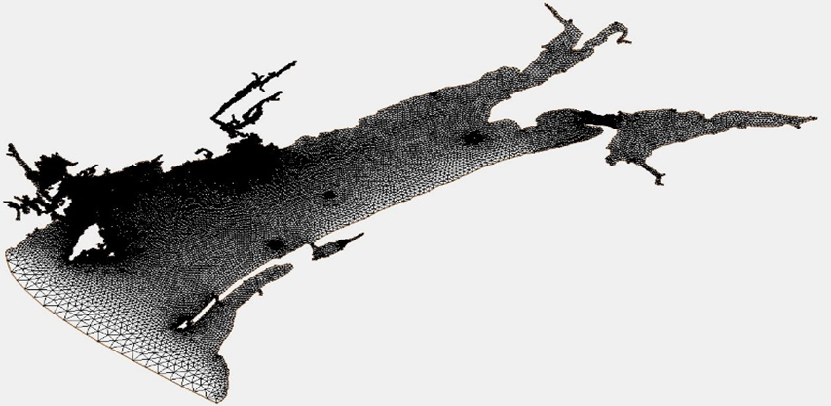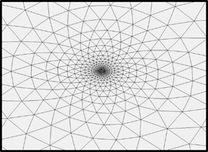

The coastline dataset is extracted from Global Self-consistent, Hierarchical, High-resolution Geography Database (GSHHG) (Wessel, P. and Smith, W.H.F., 1996) with the full resolution. The model bathymetry is a 100-m resolution from CHS and Natural Recourses Canada (NRCan) and the areas which are not covered by this dataset, such as Chignecto Bay, the entrance of Passamaquoddy Bay, and close to Bear Cove, are digitized from chart numbers 4010, 4011, 4012, 4013, 4117, 4396. Part of the Saint John River is covered by CHS bathymetry data and the rest is from University of New Brunswick Ocean Mapping Group dataset(McNeill et al., 2018). For the two high-resolution spots in the second mesh, the 10-m resolution bathymetry is provided by the NSCC (Nova Scotia Community College).

The mesh is generated by the Surface Water Modeling System (SMS 12.1) which is commercial software for creating the unstructured grid with different modules (Map, Mesh, and Scatter) that are necessary for FVCOM (Chen et al., 2006). The mesh quality recommendation for FVCOM is as follows based on the FVCOM manual: The Minimum interior angle is 30 degrees, maximum interior angle of 130 degrees, the maximum slope 0.1, the Element area change 0.5, and the connecting elements 7. The total number of nodes and elements for the coarse and fine resolution are 34871, 64765 and 35649, 66321 respectively. The horizontal resolution ranges from 6km in the open boundary attached to the Gulf of Mine to 20 m in the Reversing Falls Saint John River and finally to 10 m in the two high-resolution spots. In the vertical coordinate, 40 uniform sigma layers have been applied.

For time integration, the mode-split scheme is used to separate the time step between the internal (baroclinic) and external (barotropic) mode. The time steps for a barotropic run for internal and external mode is set to 0.5 s, and for baroclinic run 0.3 s and MY-2.5 is used as vertical turbulence closure to parametrize the vertical eddy viscosity and the vertical thermal diffusion coefficient (Chen et al., 2006). Spatially constant values for the minimum bottom roughness have been examined and the results are provided in section 3.1.

**2.2 Model initialization and open boundary forcing**

The model consists of two open boundaries, one in the upper part of Saint John River with 3 nodes and the other one is adjacent to the Gulf of Maine with 23 nodes. The surface temperature and river water level are from Environment and Climate Change Canada. The small open boundary is considered close to the Evandale area and the river water level is from the Oak station (01AP003). By using this boundary location, we can assume that we have the freshwater inflow at that point (O’Flaherty-Sproul and Haigh, pers.comm and Paquin et al, 2019). At the main open boundary, the forcing includes tidal elevation, temperature, and salinity. The tidal elevation, with five main constituents for the Bay (M2, N2, S2, K1, and O1), is extracted from an unstructured barotropic tidal model, the WebTide Scotia - Fundy - Maine model, which is tuned for the Bay of Fundy (Dupont et al., 2005).To facilitate the tuning process of tides in the Bay, we just considered the five constituents which in total need 27 days of simulation data to perform the tidal analysis. 3-hourly time series of temperature and salinity for the open boundary is extracted from Regional Ice-Ocean prediction System (RIOPS) 1/12° resolution in addition to the initialization for temperature and salinity (Dupont et al., 2015). The model is set to run in ‘hot-start’ from 1st July to 1st September 2018, with 10 hours spin up. Also, a whole year run with ‘cold-start’ configuration was conducted to evaluate the discharge of Saint John River at the spring freshet in the Bay of Fundy.

**3 Evaluation of tide and water properties**

In this section, we provide an evaluation of the model to represent the dominant features of the oceanographic conditions of the Bay and the effect of the high-resolution spots on the bottom currents. Figure 2 shows the location of CTD casts from fieldwork and the World Ocean Atlas Database during the simulation period. We evaluate the model base on the (1) tide and (2) residual currents and (3) variation in temperature and salinity.

**3.1 Tidal constituents**

The observations of water level in the Saint John Harbour is from the tide gauge located in Figure 1a. The model run period is July and August of 2018, however, there are gaps in the tide gauge data, and we compared the data from July 19th to August 27th and the result are in Figure 4.The simulated sea water level has a good agreement in phase with the tide gauge data and less than 0.6 m difference in amplitude which may result from not including all constituents and wind surge. The tide gauge data is vertically referenced to the chart datum white the water level in FVCOM is relative to the mean sea level (MSL)

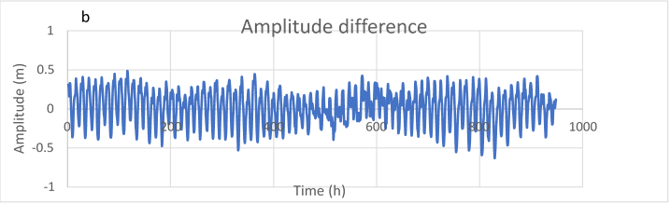

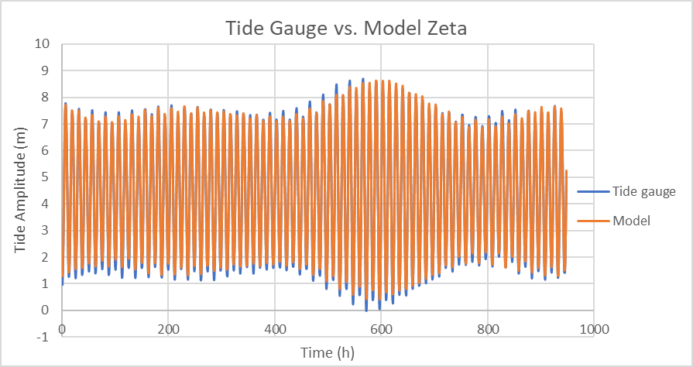

a

Figure 4..a) Comparison between tide gauge with simulated water level, and b) the difference between them. Time is hourly since 19th July until 27th August.

(Chen et al., 2006); therefore, the Canadian Continuous Vertical Datum Hydrographic Vertical Separation (HyVSEP) solution (CANEAST2015v1CL) (Robin et al., 2016) was used to relate MSL and chart datum.

The model was run with different values of the bottom roughness coefficient to evaluate which value provides a better representation of tidal propagation for the domain. A harmonic analysis (Pawlowicz et al., 2010) is performed on the simulated water level with different bottom roughness coefficients to determine the best value with the smallest error for the whole bay and the results are compared with the CHS tidal constituents in the table 1, 2, and 3. The error metric is the distance in the complex plane between observed (CHS constituents) and modeled constituents (Dupont et al., 2005) and is defined as follow:

$E= \left|A_{0}e^{i∅_{0}}- A_{m}e^{i∅_{m}}\right|$ (1)

where $A_{0}$, $∅_{0}$ are the amplitude and phase of the observed harmonic and $A_{m}$, $∅_{m}$ are the amplitude and phase of the modeled harmonic. We use this metric which combines the amplitude and phase errors in a single number for the validation.

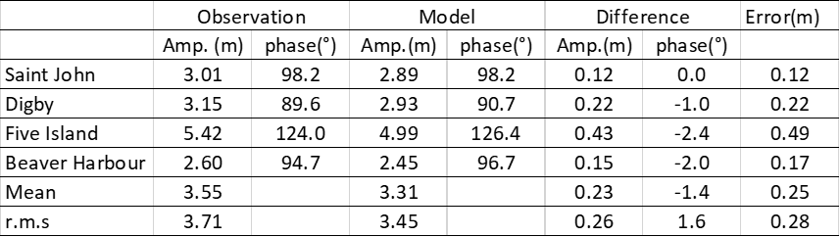

Table 1.CHS and modelled amplitude(m) and phase (degree, GMT) and discrepancies(CHS-Model) for M2 with bottom coefficient 0.015.The error is from the metric in equation 1

Table 2.CHS and modelled amplitude(m) and phase (degree, GMT) and discrepancies(CHS-Model) for M2 with bottom coefficient 0.007.The error is from the metric in equation 1

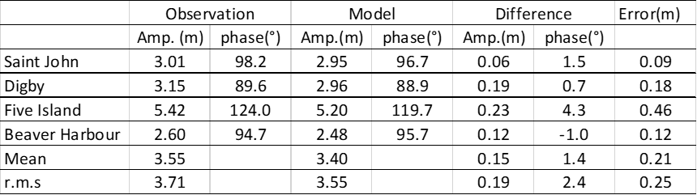

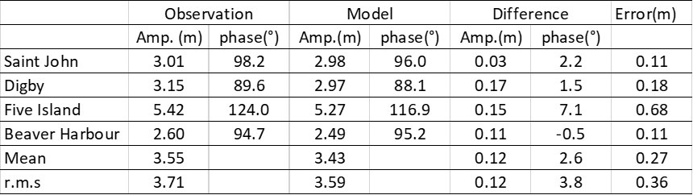

Table 3.CHS and modelled amplitude(m) and phase (degree, GMT) and discrepancies(CHS-Model) for M2 with bottom coefficient 0.005.The error is from the metric in equation 1

The r.m.s value for the M2 constituent in all four stations (Fig. 1a) with different bottom coefficient are presented in the Table 1, Table 2 and Table 3. The predicted tide by the model for Five Island and Saint John Harbour have the highest and smallest error, respectively and the minimum mean and r.m.s error results from using a bottom roughness coefficient equal to 0.007.

The validation for all five constituents against the CHS constituents is shown in Fig. 5. In total, M2, K1, O1 and N2 phases from the model tend to be larger than the CHS ones with smaller model predicted amplitude for M2 and S2 and a larger amplitude for N2. The modelled M2 constituent is close to the CHS with amplitude errors generally between 0.06 to 0.22 m and with the highest error in phase in the Five Island point which lags by about 5.1 degrees. The errors in the N2 phase range from 3.3 to 14.9 degrees while the amplitude errors are less than 0.11 m. The S2 is the only constituent that has a late phase between 9.1 and 20.3 degrees with a small amplitude error of less than 0.06 m. With phase errors between 1.8 and 10 degrees and amplitude errors of less than 0.01 m, K1 is one of the model constituents which is ahead of CHS one. Finally, O1 with no special pattern has an amplitude error of less than 0.02m and phase error of 0.7 to 11 degrees. For all three bottom roughness coefficients, it seems that the phase has more impact on the error calculation than amplitude. The comparison for M2, between our model output with 0.007 as the bottom coefficient and the WebTide model, is provided in Fig.6. The phase pattern is following the WebTide very closely and there is a maximum amplitude difference of 40 cm in the Minas Passage. These discrepancies may come from the model forcing which is not included in the model run or using a constant bottom roughness which can impact the representation and accuracy of tidal solutions (Paquin et al., 2019). By decreasing the bottom coefficient to 0.005, the water body feels less friction from the seabed and the model phase surpasses the Webtide phase (Fig. 6b), while when we increase the coefficient to 0.015, it feels more friction and the phase lags behind the WebTide phase (Fig. 6d). With the coefficient equal to 0.007, we have the best fit for our model phase (Fig. 6c). The finer mesh resolution can potentially improve model skill and the comparison with a coarse resolution (RIOPS) is shown in table 4 for the three main constituents in the Saint John Harbour; M2, N2, and S2 with an amplitude of 3.01, 0.60, and 0.49 m, respectively. The M2 amplitude improves as the resolution increase from RIOPS to FVCOM with a 10% error (33cm) to 1.9% error (6cm), respectively. The tidal constituents for RIOPS is from Paquin et al. (2019).

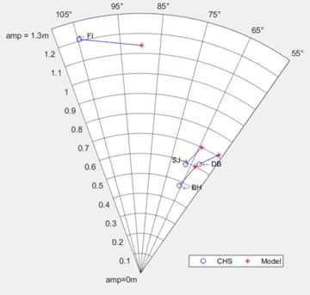

b

N2

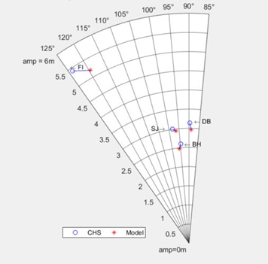

a

M2

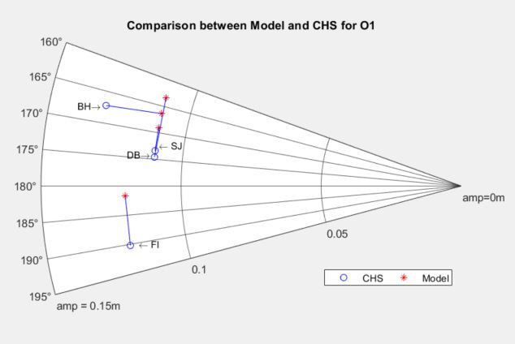

e

**O**1

Figure 5.Polar plot of the model extracted tidal constituents (red star) versus CHS (blue circles) for the five major constituents with bottom coefficient 0.007. a) M2, b) N2, c) S2, d) K1, e) O1

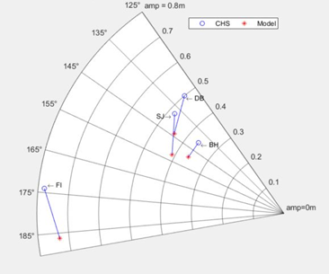

c

**S**2

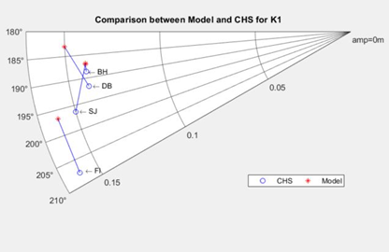

d

**K**1

Figure 6.The Amplitude(colour shading, in m) and phase(contours, in degree, GMT) of sea level for the principal lunar semidiurnal tidal constituent(M2) a) WebTide , b)Bottom Coefficient 0.005, c) Bottom Coefficient 0.007, d) Bottom Coefficient 0.015

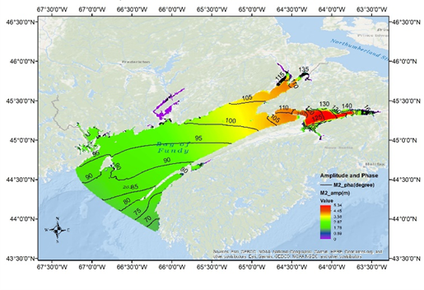

d

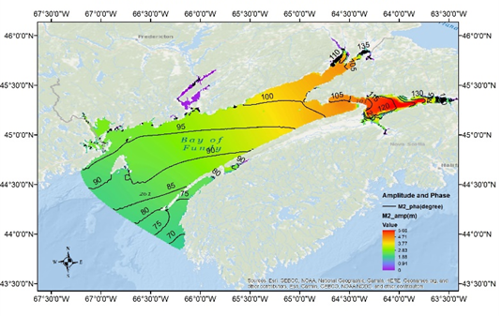

c

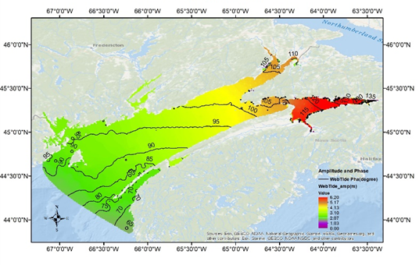

a

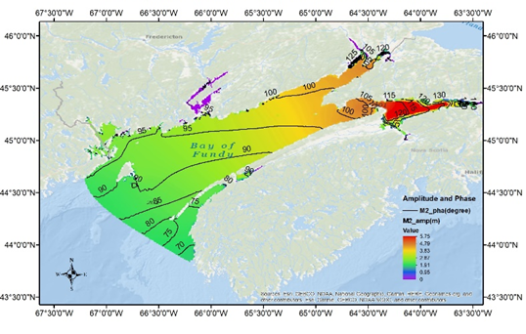

b

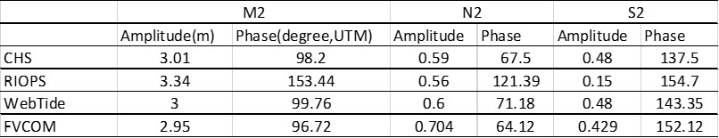

Table 4.Comparison of tidal amplitude and phase of water level for M2 at Saint John River tide gauge, WebTide, RIOPS, and FVCOM

**3.5 Tidal Residuals**

The residual flows can result from different factors, for instance, nonlinear interaction between tides, bottom topography, the geometry of the coastline, bottom friction, winds, waves, density variations and far-field general circulation (Wu et al., 2011). We compare the residuals form each model runs, Barotropic and Baroclinic. By analyzing current meter data, Bigelow (1968) showed that there is an anticlockwise gyre near Cape split due to strong mean inward and outward flow, and further analysis of these observations by Tee (1976,1977) revealed three other gyres, one clockwise gyre in Minas Channel, and two gyrs in the Minas Passage on the west(clockwise) and east(anticlockwise) side and last one(clockwise) off Cape Blomidon (Greenberg,1983; Wu et al, 2011), Fig. 7, Fig. 8, and Fig. 9 respectively.

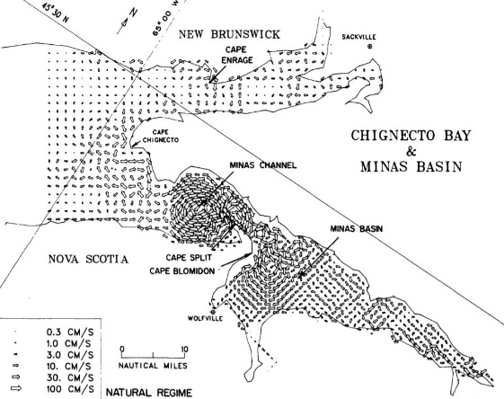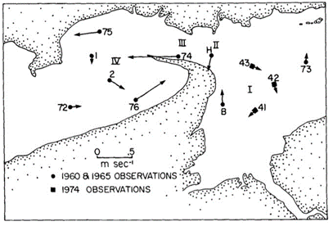

Figure 7. The residual currents in the Minas Basin and channel (from Greenberg, 1982)

Figure 8. The observed residual currents in the Minas area (from Tee, 1977)

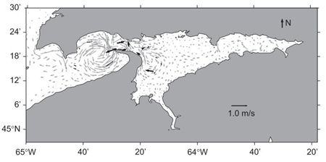

Figure 9. The depth-averaged residual flow (from Wu et al, 2011)

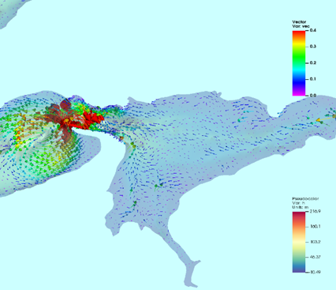

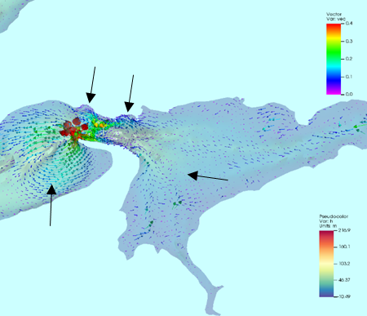

a

b

Figure 10.Tidal residual currents in the Minas Basin area and location of four gyres in (a)Barotropic run and (b) Baroclinic run

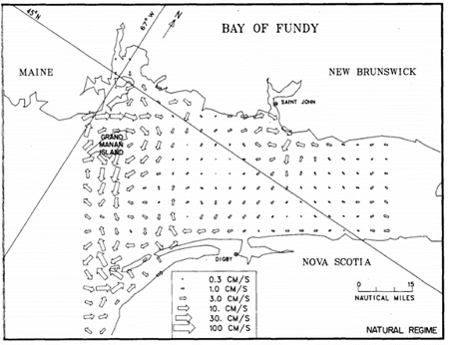The residual flow for the barotropic run is presented in Fig. 10a at the end of the simulation period, August 31st. The high-resolution grid in the model, especially in the Minas Passage and Channel, can resolve these features. It seems that the tide, complex geometry at the entrance of Minas Passage result in the generation of the gyres. There is an improvement for the residual currents in the Baroclinic run (Fig. 10b) and it shows that in the Minas Basin area, the shape of the gyre persists but the residual currents speed increase due to baroclinic effect. In the lower part of Bay, northeast of Grand Manan Island, the baroclinic effect has generated a clockwise gyre around the high gradient depth area (Fig. 12). In the lower part of Bay, northeast of Grand Manan Island, the baroclinic effect has generated a clockwise gyre around the high gradient depth area The same residual current(Fig.11) has been resolved at the entrance of the Bay (Greenberg, 1982; Isaji and Spaulding 1984).

Figure 11.Residual currents at the Bay entrance and Grand Manan Island (from Greenberg, 1982).

Figure 12.The tidal residual currents at entrance of the Bay for(a)Barotropic and (b) Baroclinic run

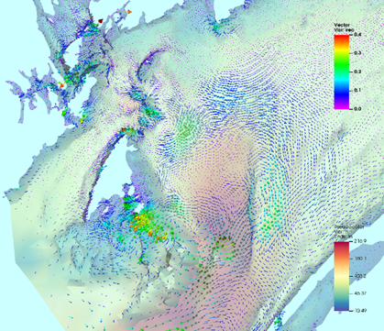

b

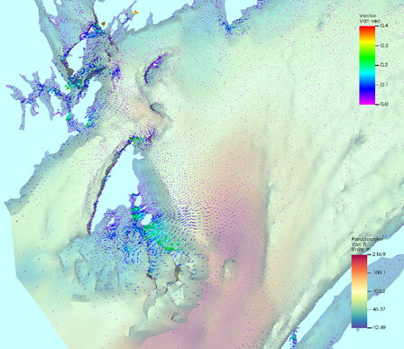

a

**3.4 Temperature and salinity variability**

The temperature and salinity are evaluated against a set of 180 CTD casts from field observations in July and August 2018 (Fig. 2) and against the World Ocean Atlas Database casts. The comparisons are provided by scatter plots in Fig.19 and the data was binned in five depth categories 3, 20, 50, 100, and 150 m. The model temperature is generally colder than observation. The salinity has less variation and the distribution is closer to the observation than temperature and it tends to be saltier in all layers. These discrepancies between the observations and model data may result from the open boundary and initialization temperature and salinity which are from RIOPS. Also, by including more surface forcing such as wind, evaporation, and precipitation in the model run, we may archive better representation of the Bay.

The temperature and salinity plots for the observation and model data show similar water mases ranging from 8 to 16 °C and 31 to 34 ppt, implying consistent temperature and salinity mixing in both the model and observations (Fig. 13 a, b). Observations show a linear relationship between salinity and temperature (Fig. 14 a). The same trend is clear in the model data but with a lower gradient (Fig. 14b).

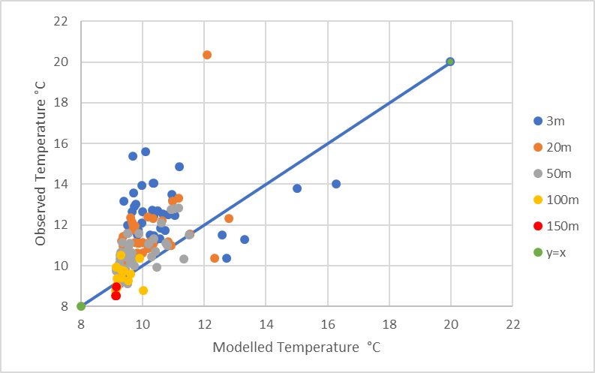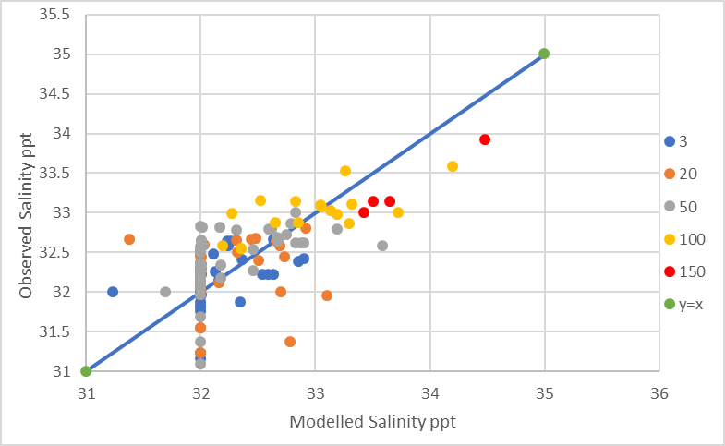

Figure 13.Scatter plots of a) salinity and b) temperature for observed and modelled data

b

a

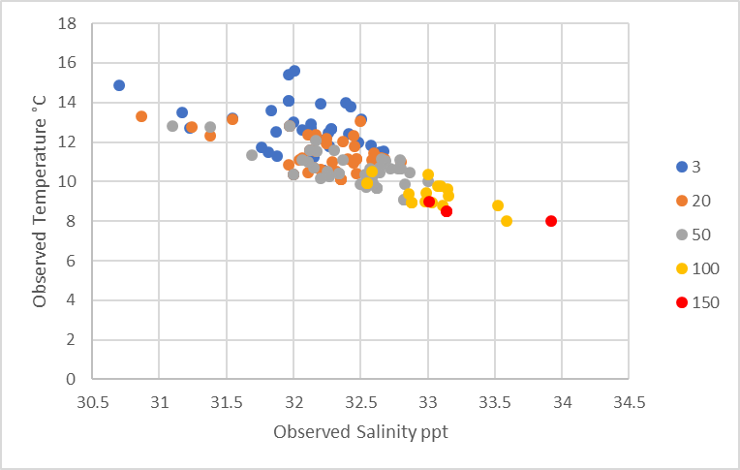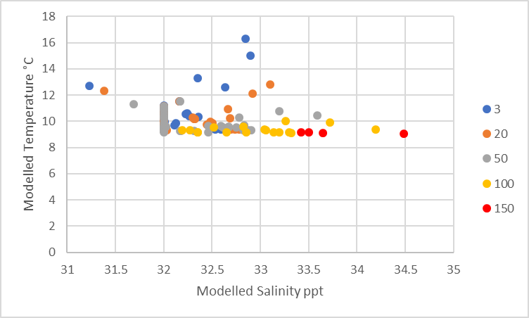

b

Figure 14.Scatterplots of the relation between salinity and temperature in the (a) observations and (b) model data

a

**3.5 Sea surface temperature**

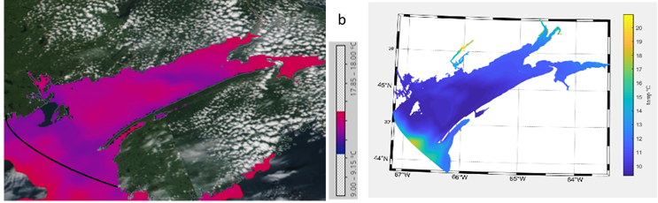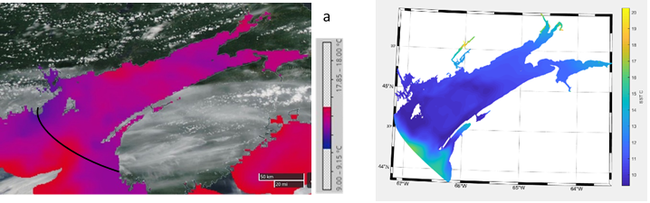Figure 15 shows the comparison between the model and sea surface temperature (SST) from the Group for High-Resolution Sea Surface Temperature (GHRSST) level 4 analysis which uses multi-scale two-dimensional variational algorithm with 1km resolution(Chao et al., 2009). Two daily and two monthly SST maps are shown in the Figure 15. On July 31(Fig. 15a), the warm water enters the Bay at the open boundary and in the middle of the bay a warmer mass is trapped between the cooler one, at the head of the Bay the water becomes cooler, and Grand Manan Island is surrounded by cooler water.

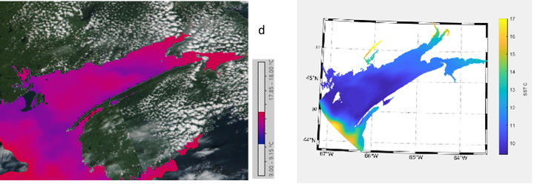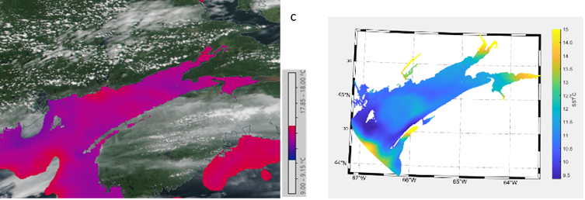

Figure 15.Daily average sea surface temperature (in Celsius) for a)July 31st, b)August 15th and monthly average for c)July and d)August for model(right) and GHRSST analysis(left).Figures from NASA World View application

On August 15th (Fig. 15b), the cold water stretches along the coast of Nova Scotia and at the head of the Bay it goes towards the middle. The warm water flows into the Bay and between Grand Manan Island and Grand Passage a mass of cold water exists, and a mass of warm water is trapped in the middle of the Bay. The same trend is observed in the model, however, the cold water on the coast of Nova Scotia does not extended to the head of the Bay.

It should be noted that the color scale is different from analysis SST on the left and the model on the right. The monthly mean SST for July (Fig. 15c) shows a different distribution of warm and cold water in the Bay and entering the warm water from the open boundary. The SST shows a warm mass of water in front of the Saint John River, but the model does not represent this, which may result from not including the effect of wind on the river surface discharge into the Bay. Mean SST in August (Fig. 15d) shows a warm mass of water in the middle of the bay, between two colder masses in both analysis and model, but more diffused in the analysis.

**4 Summary**

In this work, a three-dimensional coastal ocean model is developed based on the FVCOM. The model is configured to run in baroclinic mode by including the temperature and salinity, tidal level, and Saint John River water level. A high-resolution mesh was generated to resolve the complex geometry of the lower Saint John River to capture the freshwater plume discharge (Bricheno et al., 2013) to the Bay. The tidal level extracted from the tidal model, WebTide Scotia - Fundy - Maine, and temperature and salinity from an operational model in the area, RIOPS. The model is assessed using observational data, including temperature and salinity from CTD casts, and sea level. The model was able to predict the tide with good accuracy in Saint John Harbour, underestimating the amplitude and phase by no more than 6 cm and 1.5° for M2, 10cm and 2° for N2, and 6cm and 15° for S2. The average error for the four stations in the Bay is about 21cm and 2.1°. In the Minas Basin area, the model had the largest M2 error of 45cm which may result from using a constant bottom roughness for the whole Bay. It may be useful to increase the bottom roughness coefficient in the Minas Passage and in the Reversing Falls to improve the tidal level representation. By increasing the resolution in Minas Passage and channel, the model resolved all four gyres in that area. Also, the result of the baroclinic run showed an increase in the speed of residual currents while conserving the gyre shapes, as compared to the barotropic run. A clear clockwise residual current was generated to the northeast of Grand Manan Island on the bottom, however, the barotropic run did not generate any clockwise residual flow in that area. In the Bay of Fundy, salinity is a dominant factor in the variation of density structure and by increasing the resolution in Saint John River area, which is the main source of freshwater discharge in the Bay, the Model could capture the outflow of the river which flows on the surface close to the New Brunswick side extending to Grand Manan Island. A comparison of the model data against the CTD data showed that the model is colder and slightly saltier, and this bias may be coming from errors in the RIOPS temperature and salinity and not including the wind and heating as surface forcing in the model run.

We acknowledge the use of imagery from the NASA Worldview application ([https://worldview.earthdata.nasa.gov](https://worldview.earthdata.nasa.gov/" \t "_blank)), part of the NASA Earth Observing System Data and Information System (EOSDIS).

# References

Abbasi, M. R., Chegini, V., Sadrinasab, M., & Siadatmousavi, S. M. (2019). Correcting the Sea Surface Temperature by Data Assimilation Over the Persian Gulf. *Iranian Journal of Science and Technology, Transaction A: Science*, 43(1), 141–149.

Anderson, J.T., Van Holliday, D., Kloser, R., Reid, D.G., Simard, Y. (2008). Acoustic seabed classification: current practice and future directions. *ICES Journal of Marine Science*, 65,1004-1011.

Anderson, J.T., Van Holliday, D., Kloser, R., Reid, D.G., Simard, Y. (2008). Acoustic seabed classification: current practice and future directions. *ICES Journal of Marine Science*, 65,1004-1011.

Aretxabaleta, A. L., McGillicuddy, D. J., Smith, K. W., & Lynch, D. R. (2008). Model simulations of the Bay of Fundy Gyre: 1. Climatological results. *Journal of Geophysical Research Oceans*, 113(10), 1–16.

Aretxabaleta, A. L., McGillicuddy, D. J., Smith, K. W., Manning, J. P., & Lynch, D. R. . (2009). Model simulations of the bay of fundy gyre: 2. Hindcasts for 2005-2007 reveal interannual variability in retentiveness. *Journal of Geophysical Research: Oceans*.

Bailey, W. B., MacGregor, D. G., & Hachey, H. B. . (1954). Annual Variations of Temperature and Salinity in the Bay of Fundy. . *Journal of the Fisheries Research Board of Canada*, 11(1), 32–47.

Bigelow, H. B. (1927). *Physical oceanography of the Gulf of Maine.* Washington, D.C: U.S. Govt.

Bricheno, L. M., Wolf, N. J., Brown, J. M. (2013). Impacts of high resolution model downscaling in coastal regions. *Continental Shelf Research*, 87,7-16.

Brooks, D. (1993). A brief overview of the physical oceanography pf the Gulf of Maine. *Proceedings of the Gulf of Maine Scientific Workshop,Woods Hole*, (pp. 51–74).

Brooks, D. A. (1994). A model study of the buoyancy-driven circulation in the Gulf of Maine. *, J. Phys. Oceanogr.*, 24, 2387–2412.

Brooks, D. A., and Townsend, D. W. (1989). Variability of the coastal current and nutrient pathways in the eastern Gulf of Maine. *Journal of Marine Research*, 47, 303– 321.

Brown, J.C., Smith, J.S., Lawton, P., Anderson, T.J. (2011). Benthic habitat mapping: A review of progress towards improved understanding of the spatial ecology of the seafloor using acoustic techniques. *Estuarine,Coastal and shelf Science*, 9(3),502-520.

Burchard, H. (2002). *Applied turbulence modelling in marine waters. Lecture Notes in Earth Sciences.* Berlin: Springer Science & Business Media.

Canadian Hydrographic Service. (2006). *Canadian Tide and current tables, vol 1: Atlantic Coast and Bay of Fundy.* Retrieved from http://www.charts.gc.ca/index-eng.html

Chao, S.Y., and Boicourt, W. C. (1986). Onset of estuarine plumes,. *J. Phys. Oceanogr.*, 16, 2137– 2149.

Chao, Y., Li, Z., Farrara, J.D., Hung, P. (2009). Blended sea surface temperatures from multiple satellites and in-situ observations for coastal oceans. *Journal of Atmospheric and Oceanic Technology*, 26 (7), 1435-1446.

Chen, C., Beardsley, R.C., Cowles, G. (2006). *An unstructured grid, finite volume coastal ocean model-FVCOM user manual, 2nd edition. . Technical report SMAST/UMAS.* New Bedford: School for Marine Science and Technology, University of Massachusetts Dartmouth.

Chen, C., Liu, H., Beardsley, R.C. (2003). An unstructured grid, finite volume, three-dimensional, primitive equations ocean model: application to coastal ocean and estuaries. . *Atmospheric and Oceanic Technology*, 20(1):159–186.

Cowles, G. W., Lentz, S. J., Chen, C., Xu, Q., & Beardsley, R. C. (2008). Comparison of observed and model-computed low frequency circulation and hydrography on the New England shelf. *Journal of Geophysical Research: Oceans*, 113(9).

Cunjak, R.A., Newbury, R.W. (2005). *Atlantic coast rivers of Canada. In: Benke AC, Cushing CE (eds) Rivers of North America.* San Diego, 939–980: Elsevier Inc. (Academic Press).

Dawson, W. (1908). *Table of hourly direction and velocity of the currents in the Bay of Fundy.* Ottawa: Canada Department of Marine and Fishing.

Dickie, L. M. (1955). Fluctuations in abundance of the giant scallop, Placopecten magellanicus (Gmelin), in the Digby Area of the Bay of Fundy, . *J. Fish. Res. Board Can.,*, 12, 797–857.

Dupont, F., Hannah, C. G., & Greenberg, D.A. (2005). Modelling the sea level of the upper Bay of Fundy. *. Atmosphere - Ocean*, 43(1), 33–47.

Dupont, F., Higginson, S., Bourdalee-Badie, R., Lu, Y., Roy, F., Smith, G.C., Lemieux, J.F., Garric,G., Davidson, F. (2015). A high-resolution ocean and sea-ice modelling system for the Arctic and North Atlantic oceans. Geoscientific Model Development, 8,1577-1594.

Fish, C. J., and Johnson, M. W. (1937). The biology of the zooplankton population in the Bay of Fundy and Gulf of Maine with special reference to production and distribution. *J. Biol. Board Can*, 3, 189–322.

Garrett, C. (1972). Tidal resonance in the Bay of Fundy and Gulf of Maine. *Nature*, 238, 441–443.

Garrett, C.J.R., Keeley, J.R., Greenberg, D.A. (1978). Tidal mixing versus thermal stratification in the Bay of Fundy and Gulf of Maine. *Atmosphere-Ocean*, 16:403–423.

Garvine, R. W. (1995). A dynamical system for classifying buoyant coastal discharges. . *Cont. ShelfRes.*, 15(13),1585–1596.

Godin, G. ( 1968). *The 1965 current survey of the Bay of Fundy: A new analysis of the data and an interpretation of results, Manuscr. Rep. Ser. 8, 97 pp.* Ottawa : Mar. Sci. Branch, Energ. Mines and Resour.

Gran, H. H., and Braarud, T. (1935). A quantitative study of the phytoplankton in the Bay of Fundy and the Gulf of Maine (including observations on hydrography, chemistry and turbidity), . *J. Biol. Board Can.*, 1, 279– 467.

Greenberg, D. A. (1979). A numerical model investigation of tidal phenomena in the bay of fundy and gulf of maine. . *Marine Geodesy*, 2(2), 161–187.

Greenberg, D. A. (1983). Modelling the Mean Barotropic Circulation in the Bay of Fundy and Gulf of Maine. *. In Journal of Physical Oceanography*, 3(5),886-904.

Hachey, H. B., and Bailey, W. B. (1952). *The general circulation of the waters of Bay of Fundy, Rep. Biol. Stn. 455, 100 pp.* St. Andrews, New Brunswick, Canada: Fish. Res. Board of Can.

Isaji, T., Spaulding, M.L. (1984). A model of the tidally induced residual circulation in the Gulf of Maine and George Bank. *Journal of Physical Oceanography*, 14,1119-1126.

Katavouta, A., Thompson,K.R., Lu,Y., and Loder,J.W. (2016). Interaction between the Tidal and Seasonal Variability of the Gulf of Maine and Scotian Shelf Region. *J. Phys. Oceanogr.*, 46,3279-3298.

Li, M., & Zhong, L. (2009). Flood-ebb and spring-neap variations of mixing, stratification and circulation in Chesapeake Bay. *Continental Shelf Research*, 29(1), 4–14.

Lynch, D. R., Holboke, M. J., & Naimie, C. E. (1997). The Maine coastal current: Spring climatological circulation. *Continental Shelf Research*, 17(6), 605–634.

Lynch, D. R., Ip, J. T. C., Naimie, C. E., & Werner, F. E. . (1996). Comprehensive coastal circulation model with application to the Gulf of Maine. *Continental Shelf Research*, 16(7), 875–906.

McNeill, P., Church, I., Leger, M. (2018). Integrating Bathymetric Datasets in the Lower Saint John River to produce a Common Reference Surface. *Canadian Hydrographic Conference and National Surveyors Conference,.* Victoria, BC, Canada.

Mellor, G. L. and Yamada, T. (1982). Development of a turbulence closure model for geophysical fluid problem. *Rev. Geophys. Space. Phys.*, 20, 851-875.

Mossman, J. (2001). Bay of Fundy tides. *Geoscience Canada*, 28, (1), pp. 1– 11.

Neu, H. ( 1960). *Hydrographic survey of St. John Harbour N.B.* National Research Council of Canada,Mechanical Engineering Report MH-97.

Paquin, J. P., Lu, Y., Taylor, S., Blanken, H., Marcotte, G., Hu, X., Zhai, L., Higginson, S., Nudds, S., Chanut, J., Smith, G. C., Bernier, N., & Dupont, F. (2020). High-resolution modelling of a coastal harbour in the presence of strong tides and significant river runoff. *Ocean Dynamics*, 70(3),365-385.

Pawlowicz, R., Beardsley, B., Lentz, S. (2002). Classical tidal harmonic analysis including error estimates in MATLAB using TDE. *Comput. Geosci*, 28,929-937.

Pettigrew, N. R., Townsend, D. W., Xue, H., Wallinga, J. P., Brickley, P. J., and Hetland R. D. (1998). Observations of the Eastern Maine Coastal Current and its offshore extensions in 1994. *J. Geophys. Res.*, 103, 30,623– 30,639.

Pietrzak, J., Jakobson, J. B., Burchard, H., Vested, H.J., Petersen, O. (2002). A three-dimensional hydrostatic model for coastal and ocean modelling using a generalized topography following co-ordinate system. *Ocean Model*, 4(2):173–205.

Pingree, R. (1975). The advance and retreat of the thermocline on the continental shelf. *Journal of the Marine Biological Association of the United Kingdom*, 55(4), 965-974.

Robin, C., Nudds, S., MacAulay, P., Godin, A., De Lange Boom, B., Bartlett, J. (2016). Hydrographic Vertical Separation Surfaces (HyVSEPs) for the Tidal Waters of Canada. *Marine Geodesy*, 39(2),195-222.

Sankaranarayanan, S., and McCay, D.F. (2003). Three-Dimensional Modeling of Tidal Circulation in Bay of Fundy. *Journal of Waterway, Port, Coastal, and Ocean Engineering*, 129(3),114.

Shaw, J., Amos, C.L., Greenberg, D.A., O'Reilly, C.T., Parrott, D.R., Patton, E. (2010). Catastrophic tidal expansion in the Bay of Fundy,Canada. *Canadian Journal of Earth Science*, 47,1079-1091.

Smagorinsky, J. (1963). General circulation experiments with the primitive equations. *Mon Weather Rev*, 91(3),99–164.

SMS 12.1. (2012). Surface-Water Modeling System, Version 12.1, Reference Manual & Tutorials. Provo, Utah.

Souffleta, Y., Marchesielloa, P., Lemariéb, F., Jouannoa, J., Capetc, X., Debreub, L., Benshilad, R. (2015). On effective resolution in ocean models. *Ocean Modelling*, 98,36-50.

Swift, J.P. D., Pelletier, B.R., Lyall, A.K., Miller. (1969). Sediment of the Bay of Fundy-A preliminary Report. . *Maritime Sediments*, 5(3):95-100.

Tee, K. (1976). Tide-induced residual current,a 2-D nonlinear numerical tidal model. *Marine Research*, 17,396-402.

Tee, K. (1977). Tide-induced residual current-verification of a numerical model. *Physical oceanography*, 17,396-402.

Watson, E. E. (1936). Mixing and residual currents in tidal waters as illustrated in the Bay of Fundy. *Journal of the Biological Board of Canada*, 141-208.

Watson, E.E. (1935). Mixing and Residual Cuments in Tidal Waters as lllustrated in the Bay of Fundy . *Journal of Biological Board of Canada*, 2(2).

Wu, Y., Chaffey, J., Greenberg, D. A., & Smith, P. C. (2016). Environmental Impacts Caused by Tidal Power Extraction in the Upper Bay of Fundy. *Atmosphere - Ocean*, 54(3),326–336.

Wu, Y., Chaffey, J., Greenberg, D.A., Colbo, K., Smith, P.C. (2011). Tidally-induced sediment transport patterns in the upper Bay of Fundy: A numerical study. *Continental Shelf Research*, 31,2041-2053.

Xue, H., Chai, F., and Pettigrew, N. R. (2000). A model study of the seasonal circulation of the Gulf of Maine. *J. Phys. Oceanogr*, 30, 1111 – 1135.

# 